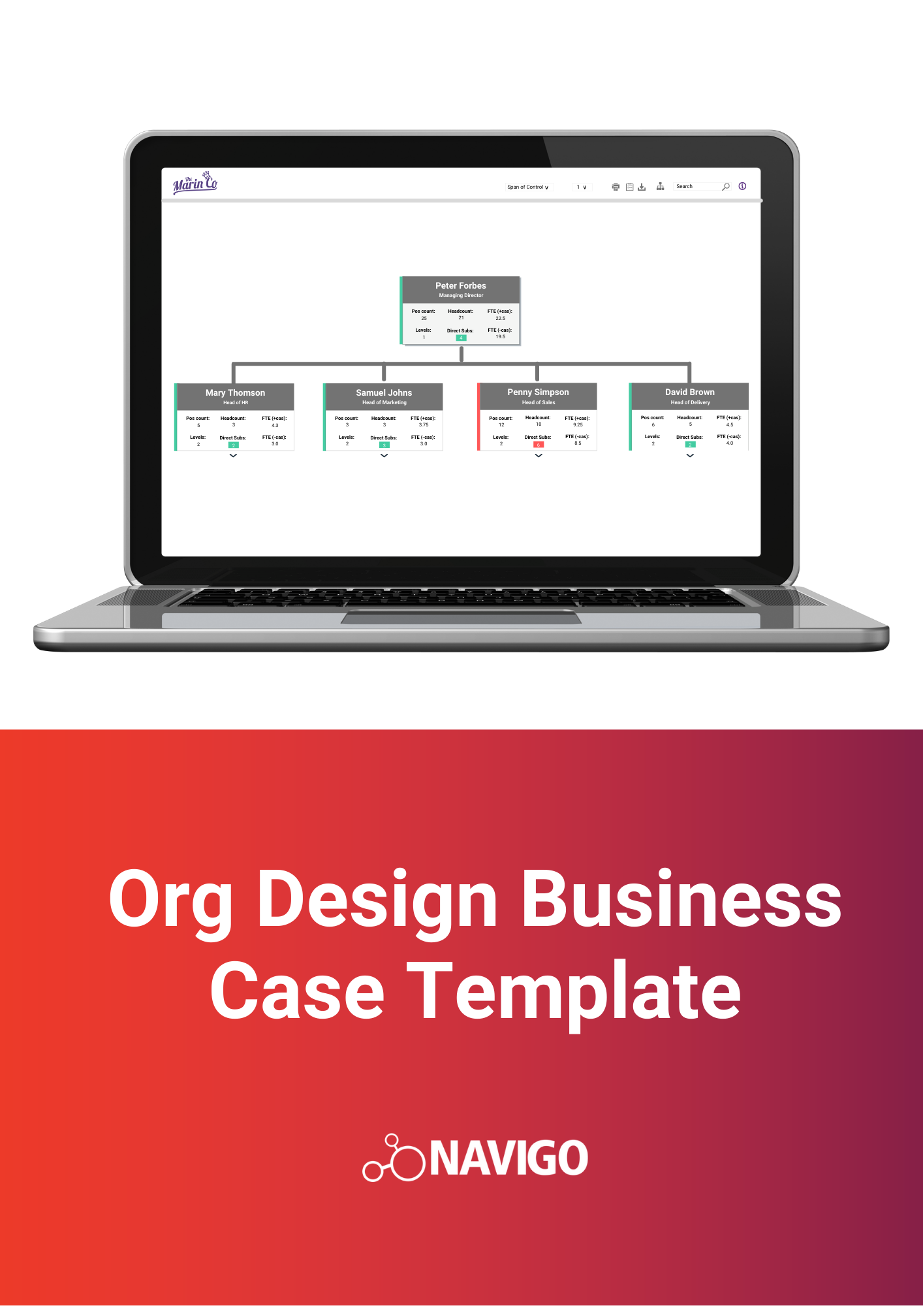

Business Case for Organisation Design Tool

<organisation name>
<organisation Address>

Version 1.0

<Date>

VERSION HISTORY
VERSION | APPROVED BY | REVISION DATE | DESCRIPTION OF CHANGE | AUTHOR

PREPARED BY |  | TITLE |  | DATE
APPROVED BY |  | TITLE |  | DATE

Table of Contents

Table of Contents 3
Executive Summary 1
Project Definition 1
Project Objectives 1
Project Scope 2
Project Delivery 3
Options Analysis 4
Evaluation of options 4
Option A 4
Option B 5
Recommended option 5
Benefits 6
Quantitative Benefits 6
Cost Estimate (for Sprint Project Example) 7
Qualitative Benefits 9
1. Designing your organisation’s future easily 9
2. Enabling you to see the bigger picture 9
3. Ability to develop a thorough planned approach 9
4. Understanding your workforce better 9
5. Creating customised dashboards 10
Appendices 10

Executive Summary
Briefly introduce the project: what it is and what needs it addresses. This should take a reader under five minutes to read and provide them with all the information needed to have a solid overview of the project and its requirements.
The key objective of this project is to find an organisation design tool that can support workforce planning, restructures and provide greater visibility of organisational structures and workforce characteristics across the organisation. The solution will be visible to all employees, however access to specific data and functionality will be determined based on roles and requirements. An organisational design tool will provide the following benefits:
- Enable improved workforce planning by providing a clear view of the organisation structure, clarity on staffing levels and easy identification of vacant positions and important workforce characteristics.
- Enable easy collaboration and assessment of workforce design proposals.
- Reduce manual workload for HR Managers and provide immediate access for Senior Managers by providing real-time, configurable, and easily viewable workforce plans, charts, and reports.
- Gain a more comprehensive understanding of the workforce using real-time data.
- Enable the capability to monitor real-time progress of the organisation design process.

Project Definition
Project Name | Project Sponsor | Project Manager

Project Objectives
Describe the expected outcomes of the project.
To implement an automated organisation design tool that will –
- Improve visibility of the workforce
- Maintain data security and data integrity throughout the organisation design process.
- Help with effectively distributing our employee resources.
- Enable scenario planning to address the peaks & troughs in workloads across the organisation.
- Remove time-consuming administration from organisation design projects work.
- Develop wider, cross-organisation thinking and alignment between business priorities and workforce structure and characteristics.

Project Scope
What’s in and out of scope for the project.
In Scope | Description
Design and Content | A review of current data and charts used within the organisation.
Change Management | Engagement with all relevant stakeholders
Project Management & Delivery | Oversee the setup, implementation, design, and configuration of customised charts.
Training | Provide training to admin and users within the organisation.

Out of Scope | Description
Additional training and chart consultation | Additional Navigo consulting and training to build customised features not included in the initial implementation plan
Development of any workflow tools | Not included in the implementation plan

Project Delivery
Describe how the project will be executed. Include high-level project phases, target completion dates, personnel, and the deliverables for each of the phases. Ensure you consider the following in your project delivery plan:
Project Delivery Element | Recommendations
Project Leadership | Responsibilities of tasks should be assigned to groups or individuals. Project scope should be clearly defined with the vendor and locked in. It needs the involvement of business units and thorough analysis of needs and requirements. Project leadership should be maintained throughout the full implementation lifecycle, including in periods of vacation or illness.
Project Team | The implementation team should be a mix of specialists, project management and skilled internal employees with the right mix of technical and business knowledge to work with the vendor.
Sponsorship | Effective implementation needs to be supported by a sponsor who can foster, accept, and lead the change for the implementation, including fostering a positive perception of the change.
End User Involvement | Impacted users need to be involved in requirements development and later in planning and implementing within their area of responsibility.
Communications | Communication at each level of the impacted groups is essential, and across all the stages of the implementation cycle. Importance must be given to user inputs – their comments and reactions.
Deployment | Thorough testing must involve relevant users in UAT to ensure the configured solution meets needs.
Training | Ensure time is allocated for training of impacted users.

Options Analysis

Evaluation of options
Provide an overview of options. For each option, the following information should be provided:
- Benefits and disadvantages
- Costs: total costs for all deliverables, risk buffers, and project management activities. Include direct and indirect costs.
- Risks: include risks such as vendor risk, security risk, data risk

Option A
Option description | Benefits | Disadvantages | Costs | Risks
Navigo’s organisation design solution | Enhanced user experience  Gain instant access to current business focused HR analytics.  Create customised charts including corporate/employee directory, management dashboards, workforce modelling and more.  Create multiple what-if scenarios and simulations with simple drag-and-drop functionality  Save time in workforce planning administration as charts update automatically.  Configure the data to show department, position and/or employee data.  Advanced search and filter based on department, business unit, name, and position.  Organisation charts can be exported to excel, pdf and PowerPoint and restrictions can be placed on print and export functions.  Single source of truth including combining structures from different entities and different payroll systems  Securely manage reviews and approvals for organisation design changes  All changes can be updated back into the core HRMS |  | Variable based on organisation size

Option B
Option description | Benefits | Disadvantages | Costs | Risks

Recommended option
Describe the preferred option with detailed justification.

Benefits

Quantitative Benefits
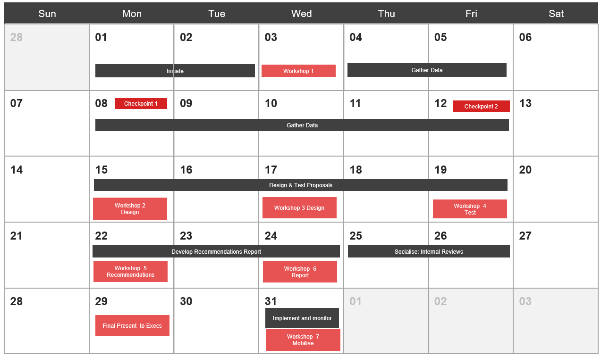
- Place a value on current organisation design efforts without any specialised tools: The below is an illustration of the costs that may be involved in a one-month sprint organisation design project with no specialised organisation design or modelling tools involved; assume a workforce of about 3000.

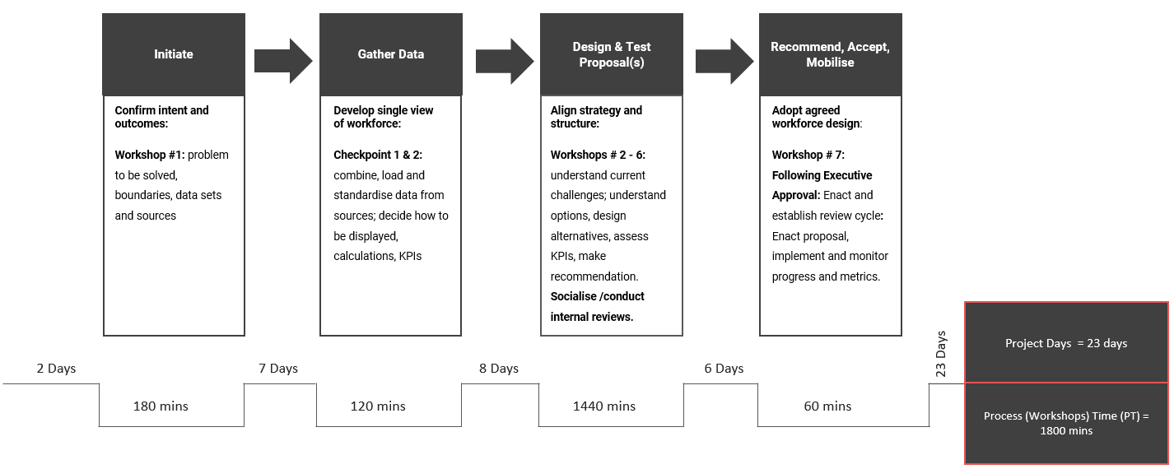
Phase | Estimated completion time | Plan
Initiate organisation design project | 2 days + 180 minutes workshop (Process Time) | Define scope, outcomes, and team
Define data and analysis  Define data model | 7 days + 120 minutes workshops (Process Time) | - Datasets  - Source systems  - Metrics  - Determine how you want data to be represented
Design and test proposals | 8 days + 1440 minutes workshops (Process Time) | Understand current challenges, understand workforce alternatives, and develop options to align structure to strategy
Recommend, accept, and implement | 6 days + 60 minutes workshop (Process Time) | Gain approval for structure change and then go ahead to implement and monitor.

Cost Estimate (for Sprint Project Example)
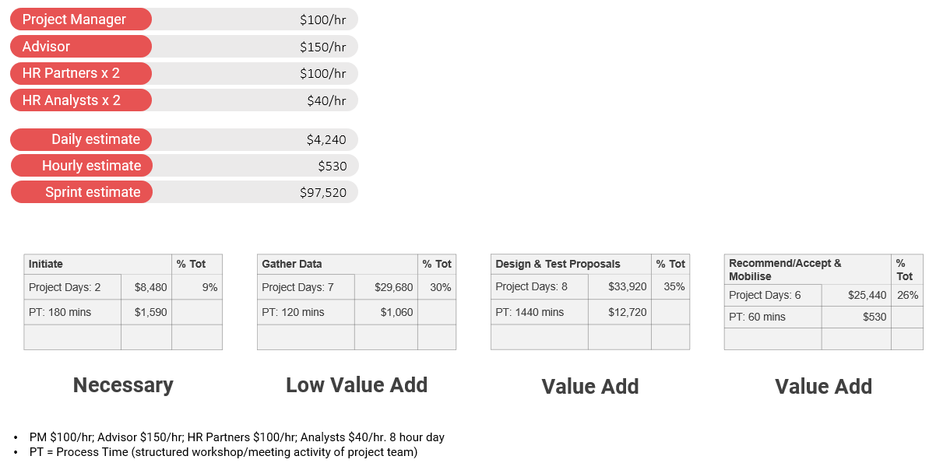
List out the costs associated at each stage of the project. Example provided below:
- Place a value on the benefits arising from an organisation design tool that covers extended benefits from workforce visualisation, analysis, and design: Example table below to illustrate benefits (the benefits are indicative estimates only, based on benchmarks and assumptions for a company with 3000 employees)

Value Driver | Baseline Calculations | Best Practices | Potential Improvement | Annual Benefits
Improve content search, knowledge sharing and collaboration. | Time lost in hrs per HR analyst * Workweeks per Year * Effort Percentage * Number of HR Analysts * Hourly Cost * size of workforce.  1 * 46 * 30% * 2 *  40 AUD * 3000 = $3,312,000 AUD | Use different organisation structure views (vertical, horizontal, graphical) to gain deeper understanding of the business & KPIs for decision-making.  Select appropriate balance of commercial and organisational decisions during restructures, mergers, and acquisitions. | 5% | $165,600
Reduce HR time on reporting. | Number of HR FTE * HR FTE fully loaded cost * Percentage time spent on functional and ad hoc reporting + External consulting spend (Estimate 3.5% of total HR costs)  30 * 150,000 AUD* 10% + 157,500AUD =  $607,500 AUD | Individually calculate, visualise, update, and share KPIs in real time while performing simulations. | 5% | $30,375
Reduce workforce planning costs. | HR Team Size * % HR Headcount for workforce planning * HR FTE fully loaded cost  (Estimate 15% of total HR costs associated with strategic / resource planning)  (30 * 15%) * 150,000 = $675,000 AUD | Improve HR productivity through integrated tools and analytics for workforce planning:  - Strategic and integrated with business plans.  - Able to take an internal and external view.  - Fully quantifiable  - Agile to respond to supply & demand | 20% | $135,000
Reduce compliance costs. | Number of HR FTE on Compliance Management * Average Cost per HR FTE + HR Compliance Management External Audit Spend [Average External Spend as a percentage (Estimate) of Total HR Costs (3%)]  3 * 150,000 AUD + 135,000 AUD = $585,000 AUD | Improve compliance productivity through integrated tools and reporting of analytics:  - Constant vigilance across data for legislative and regulatory requirements  - Streamlined process and reporting.  - Ongoing validation of changes as they are introduced across the organisation.  - Minimal level of risk from compliance issues  - Minimal citations from external audits | 3% | $17,550

Qualitative Benefits
While quantifiable benefits are required to perform a cost-benefit analysis, it’s also useful to mention some of the qualitative benefits of implementing an organisation design tool. Here are just some examples of how an organisation design tool can help you and your team.

Designing your organisation’s future easily
The simulation functionality enables the design of future structures based on any effective date. Users can add, edit, move, and flag objects. The data can be transferred back to your payroll saving you time and manual administration work.

Enabling you to see the bigger picture
Custom metrics can be calculated and displayed. Conditional formatting and alternative display options allow the identification of critical areas in your workforce, encouraging immediate action.

Ability to develop a thorough planned approach
Display what is relevant to your organisation. Combined with custom design, content, and features, you can see the structure the way you need to make informed decisions.

Understanding your workforce better
One of the main purposes of an organisation design tool is to help you understand your workforce better. Being able to see your organisation from different perspectives and dimensions can give you a holistic view of your workforce. Navigo’s organisation design tool can provide you with information from many different dimensions, examples of which are illustrated below:
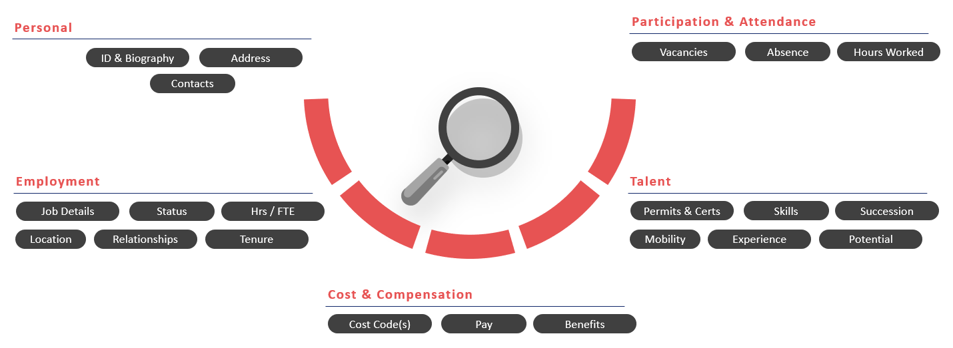

Creating customised dashboards
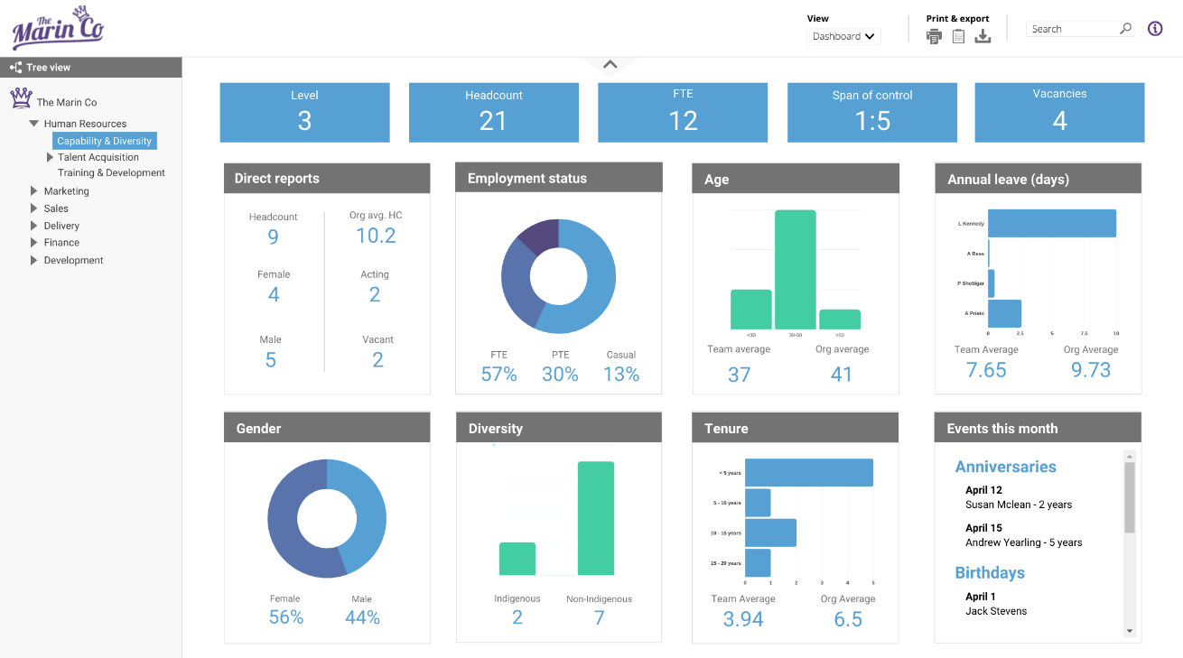
See all your key metrics and KPIs in a single view with custom dashboards.

Appendices
Include any other relevant documentation that can support your business case here.

